APPENDIX A

The following signatures are the database of the program, which used as input of the program.
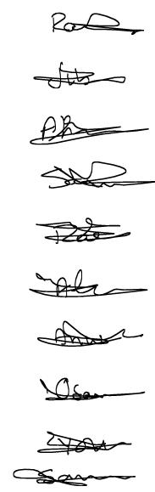
Raed
Jebreel
Ahmad
Shaher
Zaed
Ali
Anwer
Osama
Yaser
Samer

DATABASE Fragment

The following signatures are the isolated signatures after training.

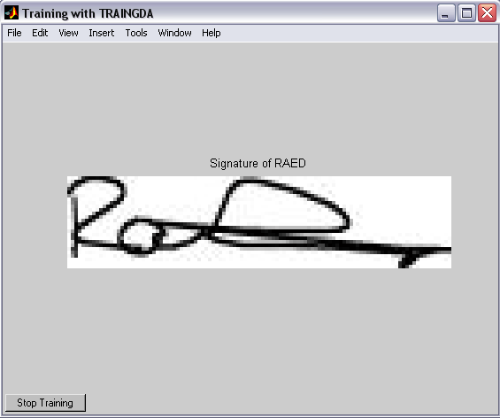

Raed’s Signature
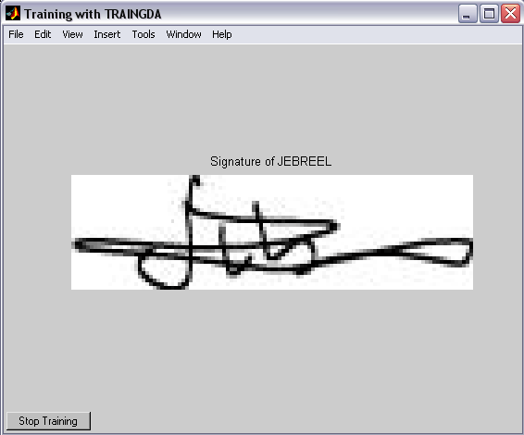

Jebreel’s Signature
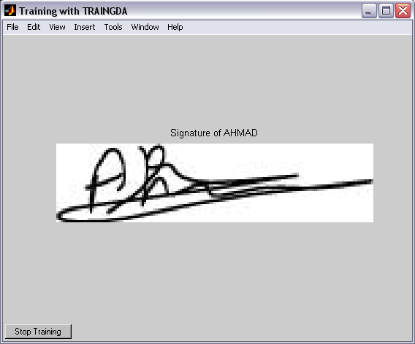

Ahmad’s Signature

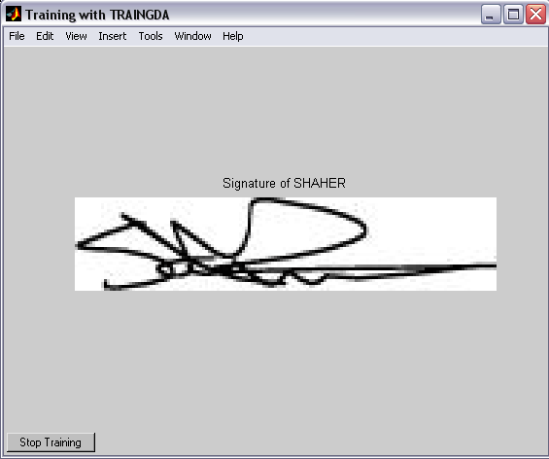

Shaher’s Signature

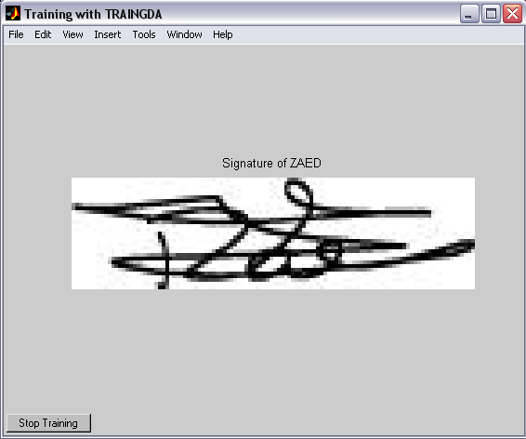

Zaed’s Signature

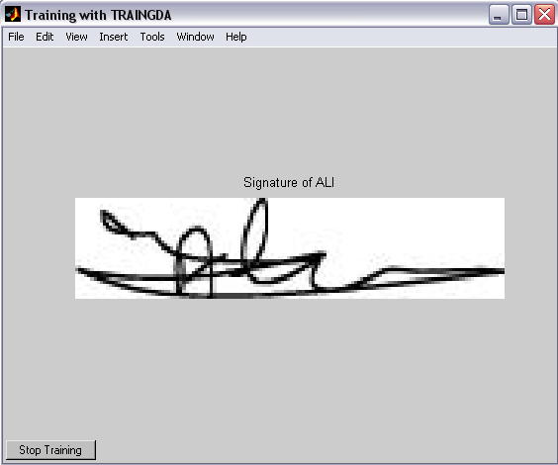

Ali’s Signature

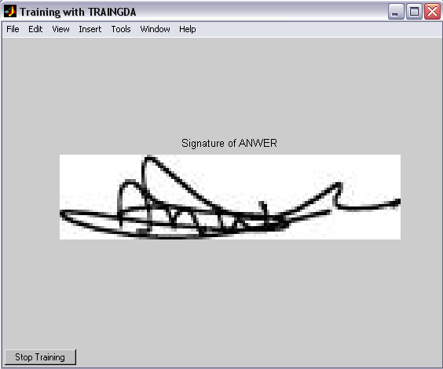

Anwaer’s Signature

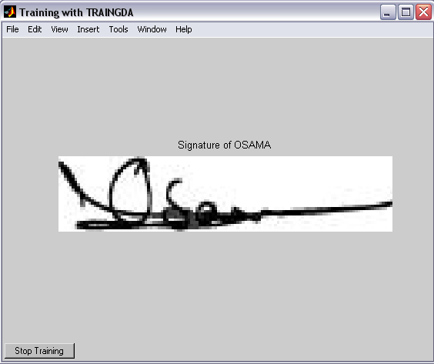

Osama’s Signature

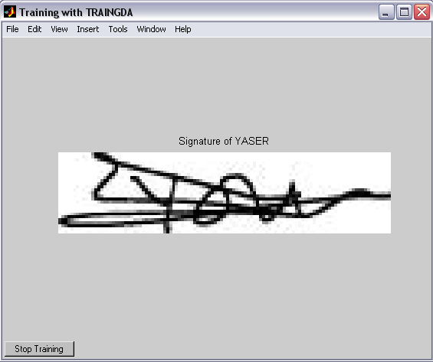

Yaser’s Signature

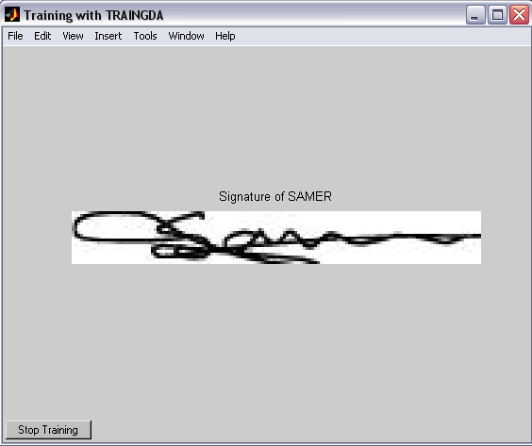

Samer’s Signature

The noisy isolated signatures Using Salt and Pepper Noise with .02 noise level.

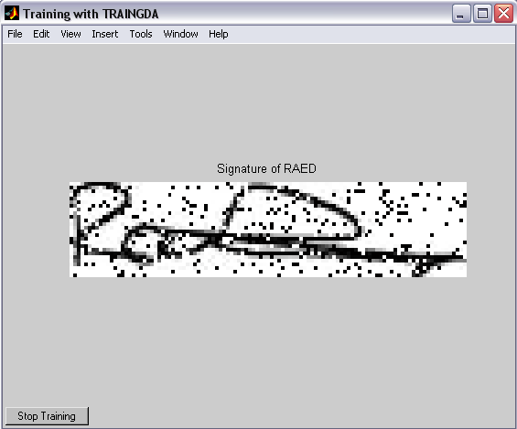

Raed’s Noisy Signature

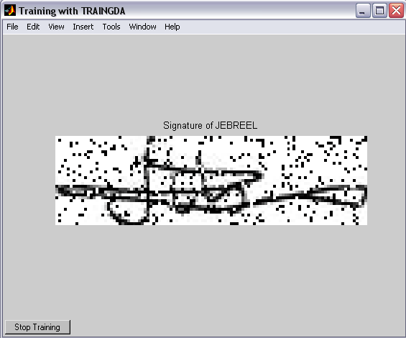

Jebreel’s Noisy Signature

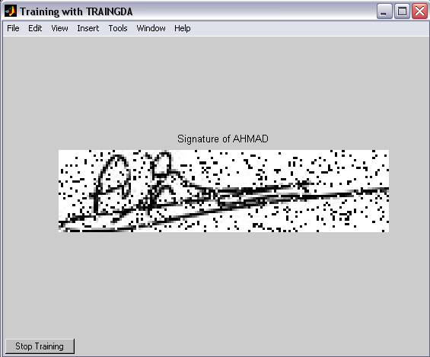

Ahmad’s Noisy Signature
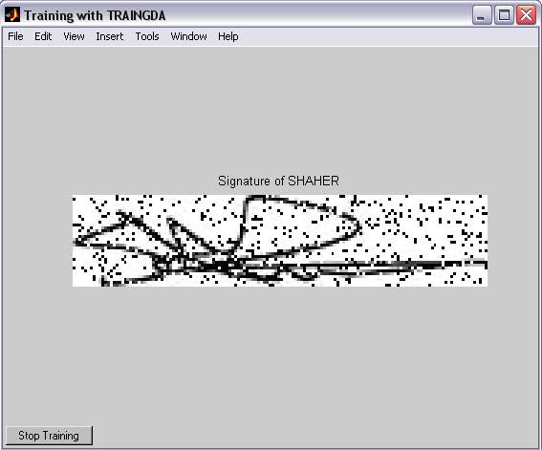

Shaher’s Noisy Signature
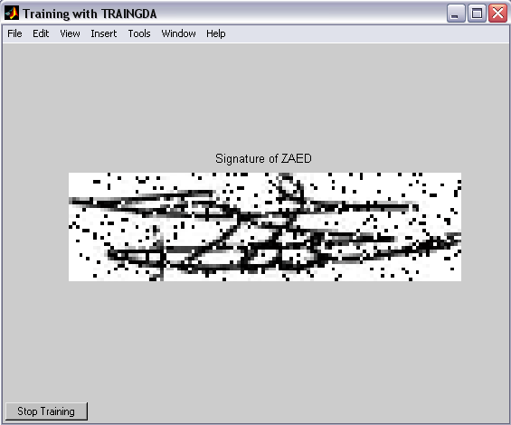

Zaed’s Noisy Signature
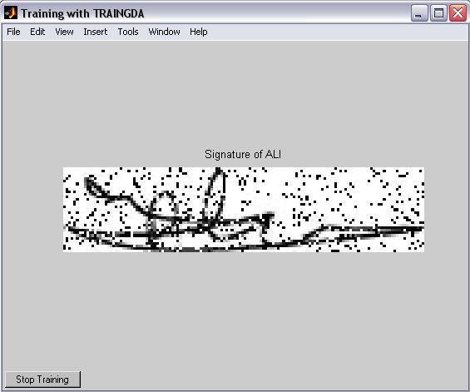

Ali’s Noisy Signature
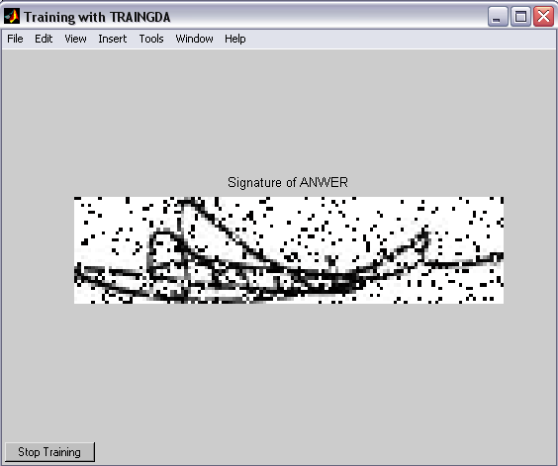

Anwer’s Noisy Signature
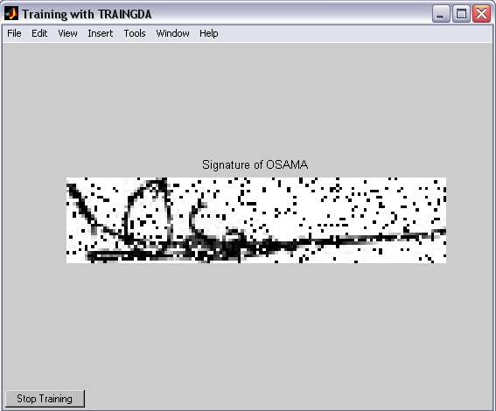

Osama’s Noisy Signature
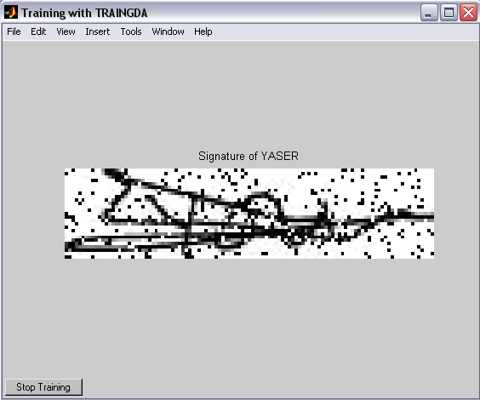

Yaser’s Noisy Signature
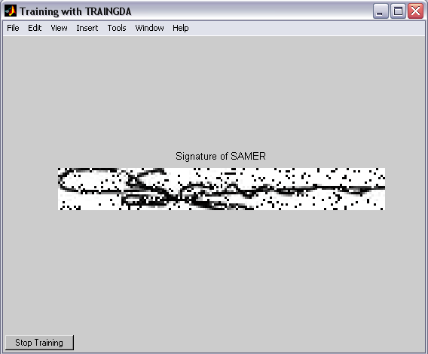

Samer’s Noisy Signature

